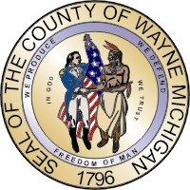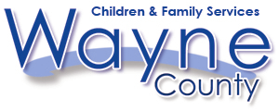
Robert A. Ficano Juvenile Services Division
County Executive

Detroit - Wayne County Community Mental Health Agency
Crisis Access Centers

`
CRISIS CENTER FOR CHILDREN | HOSPITAL CRISIS CENTERS
The Guidance Center  13101 Allen Rd  Southgate, MI 48141  734-287-1701 | Detroit Receiving Hospital  4201 St. Antoine  Detroit, MI 48201  313-745-3540 (Adults)
Starfish Family Services  18316 Middlebelt  Livonia, MI 48152  888-355-5433 | Children’s Hospital  3901 Beaubien  Detroit, MI 48201  313-745-5437  313-745-0113 Emergency Line
Starfish Family Services  30000 Hively  Inkster, MI 48141  734-728-3400 | St. Johns Riverview Hospital  4777 E. Outer Drive  Detroit, MI 48234  313-369-5689 (Adults)
St. Johns Detroit Riverview Hospital
7733 E. Jefferson
Detroit, MI 48214
313-499-4970 (Adults)

