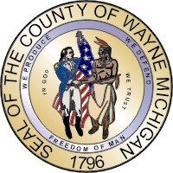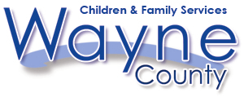
Robert A. Ficano Juvenile Services Division
County Executive

JUVENILE JUSTICE SERVICES HANDBOOK
SUBJECT: Managing for Results | PAGE: 1 of 2
ITEM: 1000.01 | DATE: 01/04/2010

I. Policy

Managing for Results is a complete management and leadership strategy that brings together people, resources and results for customers. MFR demonstrates accountability to the tax payers.

II. Definitions

A. Department of Children and Family Services Mission – To provide quality assessment, prevention, treatment, education, detention, and enforcement services to at-risk and adjudicated juveniles and adult offenders so that they can lead law abiding and productive lives.

B. Juvenile Services Division Mission – To provide intake, assessment, community-based and residential treatment services to adjudicated juveniles so that they can live law abiding lives.

C. Managing for Results System – MFR means that an entire organization, its management system, its employees and the organizational culture (beliefs, behavior, and language) are focused on achieving results for the customer. MFR provides direction for making good business decisions based on performance, and make departments accountable for results.

D. Performance Result – Measures benefit to customer from receiving program services.

E. Strategic Plan – A Strategic Plan sets forth the mission, strategic goals, performance measurements for the department and County. A Strategic Plan provides information to the department staff and public about how the department is organized to deliver results and what results the department is accountable for achieving.

F. Wayne County Mission – To lead the nation in providing exemplary and efficient services that continuously promote and enhance the highest quality of life for those who choose to live, work, visit and play in Wayne County.

III. Procedure

- The Juvenile Services Division is responsible for participating in the development of the Department’s annual Strategic Business Plan.

- The JAC and CMOs are required to provide the Wayne County Department of Children and Family Services (CAFS) with a monthly report for defined performance results. The report is due to the Assistant Director, Juvenile Services Division on or about the 10th calendar day of the month. The template presented in Exhibit 1000.1-A will be used to report performance results data.

IV. Exhibits

1000.1-A Monthly MFR Performance Results Report Template

V. References

Wayne County Strategic Business Plan

