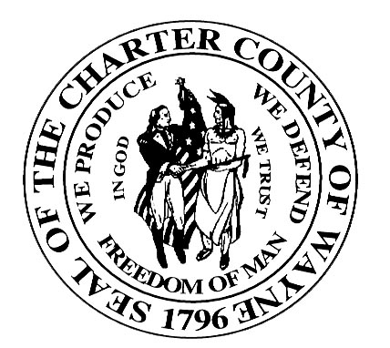

Wayne County Department Of Children and Family Services

JUVENILE SERVICES DIVISION

JUVENILE JUSTICE SERVICES HANDBOOK
SUBJECT: Criminal History Checks:  Employees and Volunteers | PAGE: 1 of 4
ITEM: 1000.7 | DATE: 10/1/2003

Policy

- The screening of potential employees and volunteers is a critical step in ensuring the safety of youth to be served by JAC’s, CMO’s and their Provider Agencies. Pre-employment checks should be used, and should include criminal background checks obtained through federal, state and local law enforcement agencies. Criminal background checks should be carried out with adequate protections for confidentiality and an individual’s civil rights.

1. JAC/CMOs and all CAFS Contract agencies are required to develop policy and procedures to ensure that all current and prospective employees have been properly screened for a criminal record and/or child abuse.

- Pre-employment checks should not be viewed as a guarantee of the safety of youth. Systematic and continued attention should be given to the quality of the staff in service settings, not only in the hiring process, but also by providing continuing supervision, as well as mandatory training.

- It is essential to screen employment and volunteer candidates criminal records and substantiated child abuse or neglect.

1. It is recommended that CMOs require their subcontractors to mandate annual Child Abuse and Neglect Registry clearances.

- Definitions

None

- Procedures

A. Each JAC, CMO and Provider Agency should, through their application procedures, directly seek information regarding past records and through police criminal records checks. The following questions should be asked by JAC’s, CMO’s and their Provider Agencies in their hiring of staff and in their screening of volunteers:

- Has the applicant ever been convicted of any crime of violence against a person;

- Crime against children; or

- Sexual offense against children; or

- Is the applicant currently charged with any such crime?

- Has the individual been convicted of a crime that would impede his/her candidacy for a particular position?

- Is the applicant currently under investigation by a law enforcement or child protective service agency for child abuse or neglect, or assault on a child?

- Has the applicant been the recipient of a dispositional finding of substantiated child abuse or neglect as a result of an investigation into one of these alleged acts?

- For Abuse and Neglect clearances, each JAC/CMO and CAFS Contract agency is required to develop policy and procedures to ensure that current and prospective employees are cleared against the State Child Abuse and Neglect Central Registry.

- Central Registry Clearances are only for the purpose of certifying that current and prospective employees are not listed as perpetrators of child abuse or neglect;

- Clearances may only be released to “the subject of the inquiry” (the employee). The employee is responsible for releasing the information to the JAC/CMO or Contract Agency.

- The Request for Central Registry Clearance form (FIA-194, Exhibit 1000.7-A) is used to obtain the abuse/neglect clearance.

C. For Criminal Record clearances, all JAC/CMOs and CAFS Contract Agencies shall have the following information documented on a Staff Background Clearance Check form (Exhibit 1000.7-B) and, following clearance by the Warrant Enforcement Bureau, placed in their personnel file. Clearances include:

● Michigan Law Enforcement Network (LEIN) check;

● Criminal Information Management System (CRIM) check;

● Michigan Department of Corrections (MDOC) database check;

● Michigan Computerized Criminal History.

1. Completed Staff Background Clearance Check forms must be forwarded by the CMO/JAC or other CAFS Contractor to the CAFS Contract Manager for processing to the Warrant Enforcement Bureau (WEB).

a. Each Contractor must identify the agency person to whom the confidential documents will be returned. This name must be communicated to the CAFS Program Manager responsible for the Contract.

- The Warrant Enforcement Bureau will:

- Complete the Michigan LEIN, CRIM, MDOC and Michigan Computerized Criminal History clearance checks;

- Enter the results on the Staff Background Clearance Check form;

- Return the form to the CAFS Contract Manager.

- The CAFS Contract Manager will:

- Forward a copy to the identified Contract Agency contact person;

b. Retain a copy for CAFS records.

D. JAC’s, CMO’s, and their Provider Agencies should require applicants to submit the names and addresses of previous employers, as well as other references. Checks of references should inquire if they know of any reason why the applicant should not work with youth. These reference checks should be documented in the employee/volunteer records.

E. Decision making should reflect a balance between legitimate need to protect youth and the desire to avoid unnecessary denial of employment to an individual. The rationale for employment decisions should be documented.

F. JAC’s, CMO’s, and their Provider Agencies shall develop a working relationship with local law enforcement agencies and the Michigan Family Independence Agency. These relationships will allow for the expeditious screening of potential employees and volunteers.

- Exhibits

1000.7-A Request for Central Registry Clearance
1000.7-B Staff Background Clearance Check

- References

Child Welfare League of America Standards

