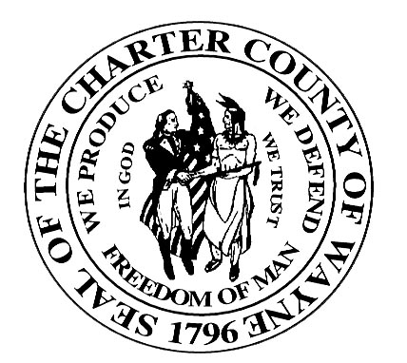

Wayne County Department Of Children and Family Services

JUVENILE SERVICES DIVISION

JUVENILE JUSTICE SERVICES HANDBOOK
SUBJECT: JAC and CMO Reporting | PAGE: 1 of 1
ITEM: 1000.6 | DATE: Development

This policy is still in development and will be released on conjunction with Juvenile Agency Information System procedures.

