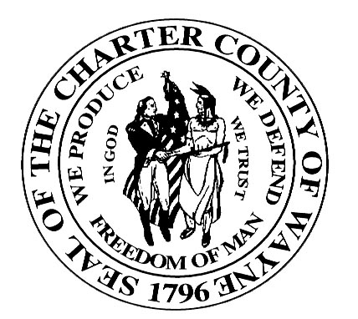

Wayne County Department Of Children and Family Services

JUVENILE SERVICES DIVISION

JUVENILE JUSTICE SERVICES HANDBOOK
SUBJECT: Training | PAGE: 1 of 3
ITEM: 1000.5 | DATE: 10/1/2003

Policy

- The CMO shall ensure that staff are provided a minimum of 50 hours new staff orientation, to be given within the first 30 days of employment. A minimum of 25 hours per year for staff development shall be provided to direct care staff.

- The CMO shall assure that all staff involved in Sexual Offender Treatment receive orientation and ongoing training to prepare them to meet the residential treatment needs of juvenile sexual offenders.

- The JAC and CMO’s shall ensure a formal training schedule is provided to all staff responsible for care of youth and prepared to support the progress made by each youth on their treatment plan. A specific plan for training shall meet applicable licensing requirements and include subject content consistent with the agency’s program focus.

- CAFS will provide periodic training specific to the Juvenile Justice Services Handbook that will include, but not be limited to:

- Organizational Structure;
- Program Eligibility;
- Court Interactions;
- Structured Decision Making;
- Balanced and Restorative Justice;
- Contract Requirements;
- JAC and CMO Responsibilities;
- Case Management;
- AOD Testing.

Definitions

None
JUVENILE JUSTICE SERVICES HANDBOOK
SUBJECT: Training | PAGE: 2 of 3
ITEM: 1000.5 | DATE: 10/1/2003

Procedures

- According to Licensing Rules for Child Caring Institutions Rule 400.4128, the licensee shall provide an orientation program for new employees. The orientation shall include the following:

- The institution’s purpose, policies and procedures, including discipline, crisis intervention techniques and emergency safety procedures.

- The role of the staff members, as related to service delivery and protection of the children.

- There shall be a written plan of ongoing staff training related to individual job functions in CMO’s and JAC’s.

- The CMO will ensure that each provider of direct care provides a minimum of 50 clock hours of planned training within the first year of employment and a minimum of 25 clock hours of training annually thereafter.

Training opportunities shall include all of the following:

- Developmental needs of children;
- Child management techniques;
- Basic group dynamics;
- Appropriate discipline, crisis intervention and child management techniques;
- The direct care worker’s and social service worker’s roles in the institution;
- Interpersonal communication;
- Proper and safe methods and techniques of restraint;
- First Aid.

Documentation will be maintained that will confirm the completion of licensing training requirements.

- CAFS will coordinate with JAC’s and CMO’s in the provision of the initial/ongoing training.
JUVENILE JUSTICE SERVICES HANDBOOK
SUBJECT: Training | PAGE: 3 of 3
ITEM: 1000.5 | DATE: 10/1/2003

Exhibits

None

References

Licensing Rules for Child Caring Institutions

