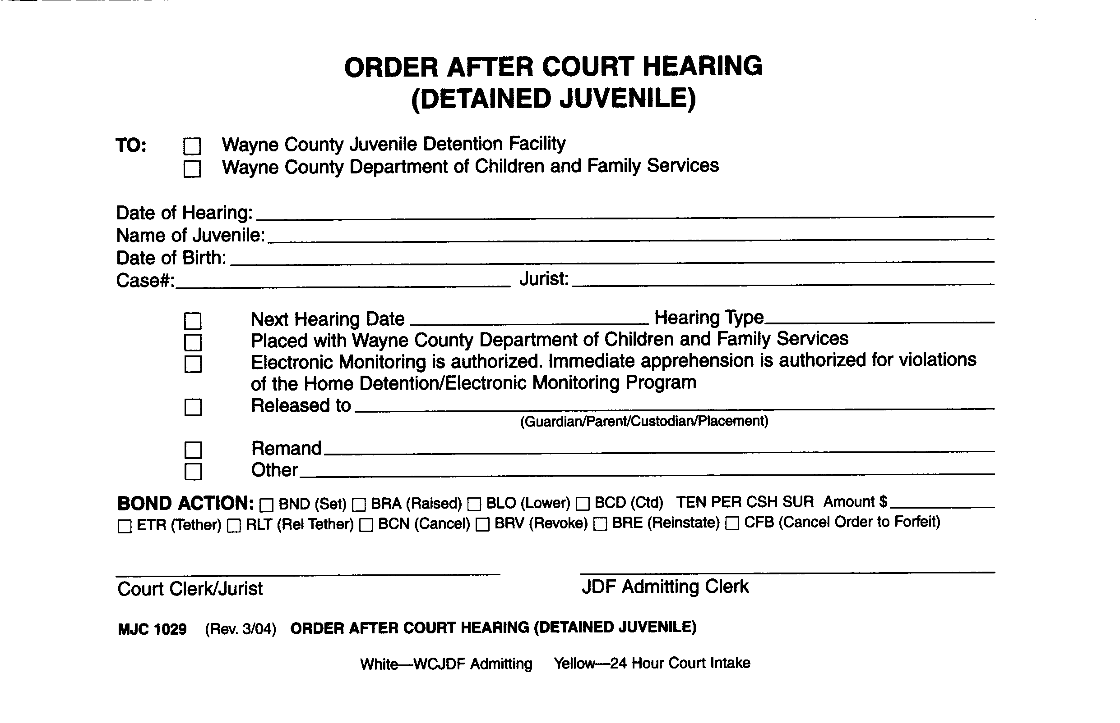
Exhibit 500.4-B (3-04)

