Exhibit 402.4-B

WAYNE COUNTY DEPARTMENT OF CHILDREN AND FAMILY SERVICES

JUVENILE SERVICES DIVISION

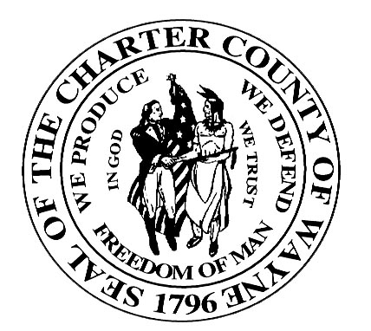

Robert A. Ficano
County Executive

Date

Carol Slotke, Director
Juvenile Justice Assignment Unit
8701 E. M 36
Whitmore Lake, Michigan 48189

Re: Resource Certification
Name:
DOB:

Dear Ms. Slotke:

This letter is to provide certification that a private agency bed, suitable for the above youth, was not available within our CMO contract network. We are therefore referring this youth for placement in an FIA Juvenile Justice facility.

Sincerely,

Case Manager
Name of CMO
Phone Number

Attachment(s)

