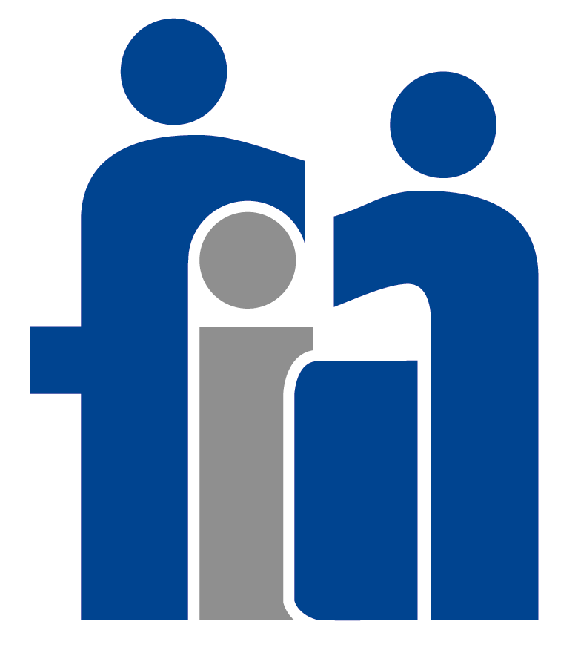
STATE OF MICHIGAN
Family
Independence
Agency

JUVENILE JUSTICE DIVISION
235 S. GRAND AVENUE
P.O. BOX 30037
LANSING, MICHIGAN 48999
(517) 335-3489
Kenneth Hale, DIRECTOR

DIRECTORY OF PROGRAMS

Juvenile Justice Assignment Unit
Director: Carol Slotke
8701 E. M36
Whitmore Lake, Michigan 48189
Phone: (734) 449-3389

W. J. Maxey Training School Arbor Heights Center (Co-ed)
Director: Derek Hitchcock Acting Director: Rick Richard’s

P.O. Box 349 1447 Washington Heights
Whitmore Lake, Michigan 48189 Ann Arbor, Michigan 48104
Phone: (734) 449-4422, Ext. 239 Phone: (734) 994-1730
Fax: (734) 449-3003

Adrian Training School
(Co-ed)
Director: Dennis Swiggum
Woodland Center Box 218
Director: Derek Hitchcock Adrian, Michigan 49221
Phone: (734) 449-4422, Ext. 264 Phone: (517) 263-2104

Huron Center (Males) Sequoyah Center (Males)
Acting Director: Mike Johnson Director: Sandra Bow
Phone: (734) 449-4422, Ext. 210 Phone: (734) 449-422, Ext. 374
.

FIA JJS and POC
Director: Charles Thornton
Western Wayne CFS 25350 Ecorse Road
Taylor, Michigan 48180
Phone: (313) 295-8258
Fax: (313) 295-8126

Residential Care Centers

Flint House (Males) Academy Hall (Males)
Director: Frank Hoese Director: Dean Miedema
1526 W. Court St. 818 S. Park St.
Flint, Michigan 48503 Kalamazoo, Michigan 49001
Phone: (810) 235-8913 Phone: (616) 337-3614

Parmenter House
Park Place (Females) (Males)
Director: Director: Frank Hoese
1027 Park Place 706 5th Street
Kalamazoo, Michigan 49001 Bay City, Michigan 48716
Phone: (616) 337-337-3618 Phone: (517) 893-5451

Pine Lodge (Males)
Director: Mike Opsommer
227 N. Sycamore St.
Lansing, Michigan 48933
Phone: (517) 334-770

