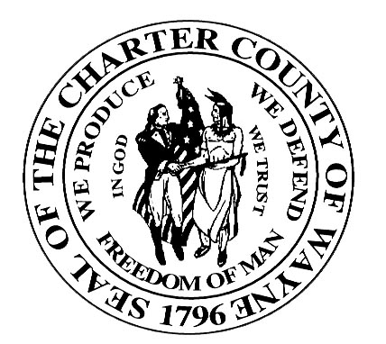

Wayne County Department Of Children and Family Services

JUVENILE SERVICES DIVISION

JUVENILE JUSTICE SERVICES HANDBOOK
SUBJECT: Restitution | PAGE: 1 of 3
ITEM: 401.16 | DATE: 10/1/2003

I. Policy

- Restitution is a key concept within a Balanced and Restorative Justice (BARJ) approach (see Item 700.15). Restitution is a fundamental right that should be afforded all victims.

1. At the dispositional hearing for a juvenile offense, the Court shall order, in addition to or in lieu of any other disposition authorized by law, that the juvenile shall make full restitution to any victim of the juvenile’s course of conduct that gives rise to the disposition or to the victim’s estate.

- The Prosecutor’s office is responsible for initiating contact with the victim to verify loss.

- If a juvenile offense results in damage to or loss or destruction of property of a victim of the juvenile offense, or results in the seizure or impoundment of property of a victim of the juvenile offense, the order of restitution may require that the juvenile do one or more of the following, as applicable:

- Return the property to the owner of the property or to a person designated by the owner;

- If return of all of the property is impossible, impractical, or inadequate, pay an amount equal to the greater of (a.) or (b.), less the value of any portion of the property that was returned:

- The value of the property on the date of the damage, loss, or destruction, or

- The value of the property on the date of disposition;

- Pay the costs of the seizure or impoundment, or both.

- If a juvenile offense results in physical or psychological injury to a victim, the order of restitution may require that the juvenile do one or more of the following, as applicable:
JUVENILE JUSTICE SERVICES HANDBOOK
SUBJECT: Restitution | PAGE: 2 of 3
ITEM: 401.16 | DATE: 10/1/2003

- Pay an amount equal to the cost of actual medical and related professional services and devices relating to physical and psychological care;

- Pay an amount equal to the cost of actual physical and occupational therapy and rehabilitation;

- Reimburse the victim or the victim’s estate for after-tax income loss suffered by the victim(s) as a result of the juvenile offense;

- Pay an amount equal to the cost of psychological and medical treatment for members of the victim’s family that has been incurred as a result of the juvenile offense;

- Pay an amount equal to the costs of actual homemaking and child care expenses, incurred as a result of the juvenile offense.

- If the victim or the victim’s estate consents, the order of restitution may require that the juvenile make restitution in services in lieu of money.

- The Court shall order restitution to the crime victims compensation board or to any individuals, partnerships, corporations, associations, governmental entities, or other legal entities that have compensated the victim or the victim’s estate for a loss incurred by the victim to the extent of the compensation paid for that loss. The Court shall also order restitution for the costs of services provided to persons or entities that have provided services to the victim as a result of the offense. Services that are subject to restitution under this subsection includes, but is not limited to shelter, food, clothing, and transportation.

- However, an order of restitution shall require that all restitution to a victim or victim’s estate under the order be made before any restitution to any other person or entity under that order is made. The Court shall not order restitution to be paid to a victim or a victim’s estate if the victim or a victim’s estate has received or is to receive compensation for that loss, and the Court shall state on the record with specificity the reasons for its actions. If an entity entitled to restitution under this subsection for compensating the victim or the victim’s estate cannot or refuses to be reimbursed for that compensation, the restitution paid for that entity shall be deposited in the crime victim’s rights assessment fund or its successor fund.

- Definitions

- Balanced and Restorative Justice (BARJ) is an accountability and community safety model. BARJ recognizes both victim and offender restoration.
JUVENILE JUSTICE SERVICES HANDBOOK
SUBJECT: Restitution | PAGE: 3 of 3
ITEM: 401.16 | DATE: 10/1/2003

- Procedures

A. The Prosecutor initiates contact with the victim to determine any loss. This is accomplished by sending the victim a copy of the Restitution Verification Form (Exhibit 401.16-A). This information is presented at the hearing to assist the Court in establishing the amount of loss the victim has sustained.

B. When restitution is ordered by the Family Division of Circuit Court the following activities occur:

- The County Clerk’s office will monitor restitution payments that have been ordered;
- The Court JAC will forward any restitution-related documents to the assigned CMO.
- The CMO will retain the restitution documentation in the juvenile’s case file and record the information in the Juvenile Agency Information System (JAIS), see Exhibit 401.16-B.

- Information on the status of payments must be included in the Progress Review reports sent to the Court (see Item 401.9).

IV. Exhibits

401.16-A Status of Restitution Report
401.16-B Monetary Restitution Ledger
401.16-C Restitution and Reimbursement Form

V. References

Juvenile Justice Benchbook

