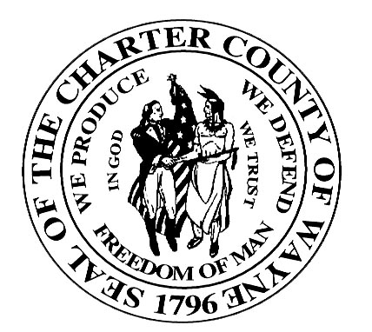
Wayne County Department of Children and Family Services
Juvenile Services Division

OBJECTION TO MPAS SERVICES

I__________________________________ object to Michigan Protection and
(Print Your Name Here)

Advocacy Service, Inc. observing or talking with my [son/daughter]

________________________________ , or making inquiries of Wayne County
(Print Youth’s Name)

Department of Children and Family Services regarding them. I request that MPAS

be denied access to my [son/daughter].

________________________
(Sign Here)

________________________
(Date)

This or similar objection must be sent to:

[Name, Title]
[Facility Address]

In the Absence of your written objection, CAFS will assume that you consent to the described activities by MPAS.

