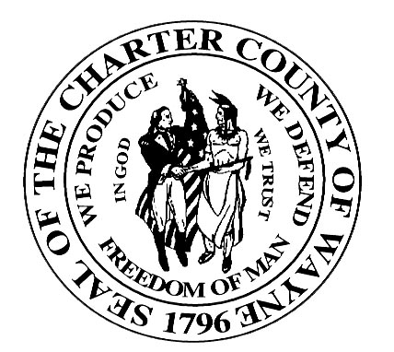
Wayne County Department of Children and Family Services
Juvenile Services Division

NOTICE OF ACCESS TO YOUTH BY MICHIGAN PROTECTION AND ADVOCACY SERVICE, INC.

TO: [Parent(s)/Guardian’s Name]

RE: [Youth’s Name]

DATE: [Current Date]

Michigan Protection and Advocacy Service, Inc. (MPAS) provides protection and advocacy services to eligible youth as set forth in the Developmental Disabilities Assistance and Bill of Rights Act (42 USC 6001 et seq.) and the Protection and Advocacy for Mental Ill Individuals Act (42 USC 10801 et seq.).

MPAS has access to Wayne County Department of Children and Family Services (CAFS) residential facilities contracted by Care Management Organizations and, in absence of your objection, may observe your [son/daughter] and speak with them or inquire from residential staff about them.

MPAS must have your written permission to examine or copy any written record regarding your [son/daughter].

If you object to MPAS providing these services to your [son/daughter], you must provide a written objection to:

[Name], [Title]
[Facility Address}

In the absence of your written objection, CAFS will assume that you consent to the above activities by MPAS.

Thank you.

[Name, Title]

