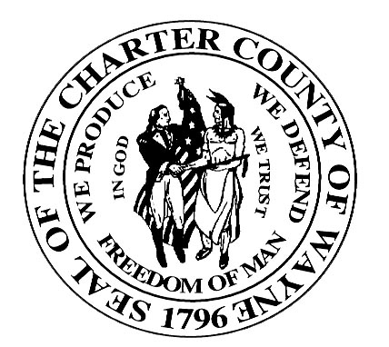

Wayne County Department Of Children and Family Services

JUVENILE SERVICES DIVISION

JUVENILE JUSTICE SERVICES HANDBOOK
SUBJECT: Juvenile Justice Glossary | PAGE: 1 of 1
ITEM: 200.1 | DATE: 10/1/2003

Policy

The JJSH will include a glossary.

Definitions

Glossary refers to a list of difficult, uncommon or specialized words or terms and their corresponding definitions.

Procedure

- The Juvenile Justice Glossary is contained in Exhibit 200.1-A.

- At the end of each definition, a cross-reference is provided for the related policy item, i.e., [401.14] in the JJSH.

Reference

None

Exhibit

200.1-A Juvenile Justice Glossary

